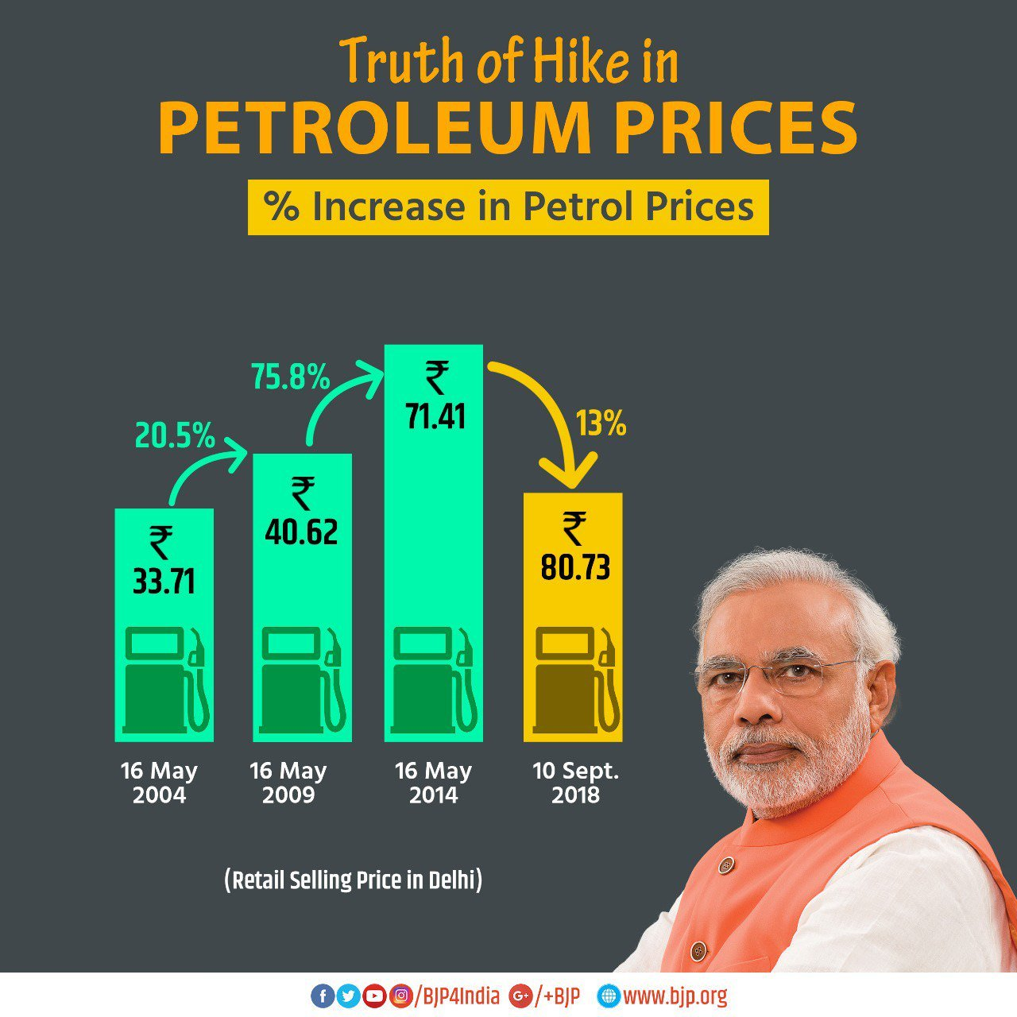

This image was tweeted in September 10, 2018 by The Bharatiya Janata Party (BJP), the ruling party of India. It was titled ‘Truth of Hike in Petroleum Prices’ to show the rate of fuel price hike over the years. BJP’s graphs depict a fall in petrol and diesel prices instead of an increase.

Link:

https://twitter.com/INCIndia/status/1039134643922984962

As this is image was tweeted on a social media account (Twitter) by the largest party in India, the intended audience is the Indian people, where regular users are expected to see this tweet.

Misleading visual components:

1. The height of Bars and The emphasized drop in % of price change

* Misuse: using graphic forms in inappropriate ways (distorting the data).
* The trimmed y-axis has led to man problems; as we can see from the image, the increase in the price from 40.62 to 71.42 is significantly larger than the previous increase (from 33.17 to 40.62), however, the differences in height were made small and close to each other.
* The drop in price in the last month was highly emphasized and enlarged, so we see that 13% is Larger than 20.5% and 75.8%
* The last bar has a price of 80.73, however, it's made shorter than the bars of 71.42 and 40.62!

1. Excluding other relevant data

* Misuse: hiding relevant data to highlight what benefits them.
* The price changes are only chosen for specific years (every 5 years) rather than showing the whole change over the years that might correspond to different values. Also, it strangely chooses different specific dates like 16 may in 2004 and 2009 but 10 September in 2018!
* Only considering the local price change and not comparing the results with the international oil prices.

What I found funny is that the official Twitter account of an Indian political movement called "The Indian National Congress"

has responded sarcastically with another tweet comparing these prices to the change in international crude oil prices, and also showing how the prices are higher than depicted even in the same year if a different month and day was considered (like August 2009 instead of May 2009)

Link:

https://twitter.com/INCIndia/status/1039134643922984962